Quick Ghost Manual (beta 0.47) 7/2024
by NWSM
v.0.2

Operators

The Operator shows you the Wavetable and Settings to modify the Wavetable in different ways.
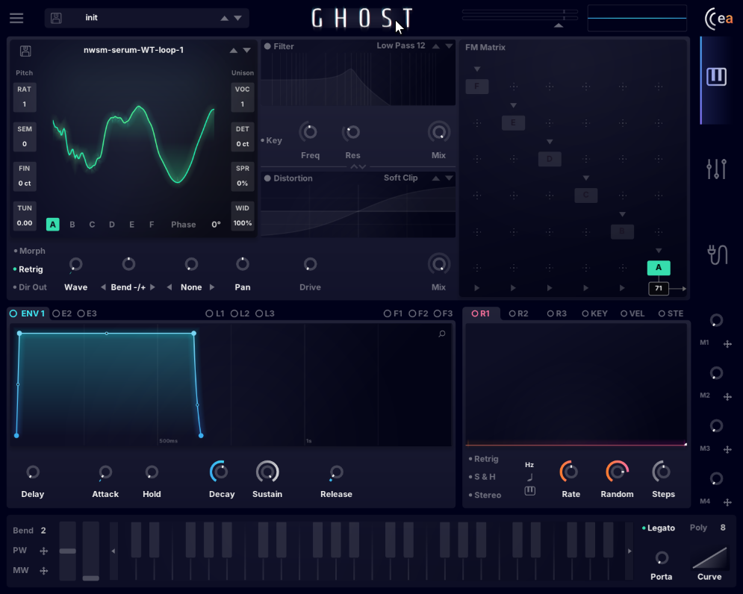
On the Top you can select and save Wavetables, on Bottom you can on/off the Operators by right click on your Mouse. Operators are from A to F, so you can play 6 Operators same time and frequency modulate them, we talk about later. On the left side you see the Parameters for RATIO, SEMI, FINE and TUN. These Parameters are Pitch Modulators. On the right Side you have Unison Parameters. If you play around with UNISON Parameters you will have a visual Feedback in the Oscillator Preview Window.
Operator
Filter & Distortion
Modulators
Operator Matrix
A right Click on the Waveform let you build a Wavetable from the actual Wavetable Setting. Below the Operator Section you have options to Bend, Tweak or Warp the Waveform with Bend, Asym, Sync, Window inside the Drop Down Menu. There is also a Morph Switch where you can scrub smoothly or hard through the Wavetable via the WAVE Knob. Two other switches are [Retrig] to retrigger the start of the Table per Note and route Audio [DIRectly to the OUT] without manipulate them with Effects. The NONE Knob on the right next to the Bend Knob contains Wavetable Filter. You will find LP, HP, Shift, Stretch for the Wavetable.
Hint: you can Stack and modulate only the Wavetable Bend Options.

Filter and Distortion
The Filter and Distortion FX next to the Operator Section are Pre-FX Effects per Operator and can be swapped. Here you can modify the Output of each Operator before it goes to the Effects Section in another Tab (watch to the right Edge of the Plugin, where u can find 3 Tabs, we talk about later). This Section do filter and distort Audio optional. You have 11 Distortion Types and 17 Filter Types. Includes Keytrack for the Filter.
swapedy
Filter & Distotion

Operator Matrix
The Operator Matrix let you FM the Wavetables you set up in the Operator Section. The Self-FM is right on Top of each Operator Switches (its an on/off Button via right click) where u can frequency modulate Operators by itself. Modulation by each other Operator via the yet bad visible cross points (more in the next section) is also possible.
Operator Matrix
Below the A Operator Switch you can set up the Output Volume of this Operator.

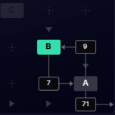
The Modulation Possibilities in the Matrix are similar to the DX7 or FM8 Synths. You can open your favorite Web Browser and search for FM-Synthesis or FM8 to have Examples how it works. The Example on the left shows an “Algorithm” where OP A and OP B fm’d each other. [A] modulates [B] with 9% and [B] modulates [A] by 7%. The Result goes to the Output from [A]. [B] is actually not hear-able and is only a Modulator for A. A is a so called Carrier, these Terms you will find also in the FM Documentations.
- https://cymatics.fm
- Algorithm chart by KORG

Modulators

Modulators can Drag and Drop on nearly each Parameter inside Ghost to use its capability for sequential or randomly modulate Parameters. These whole Section is fixed on its place so you can easy use this Modulators in the FX Section as well.
Modulators

You have 3 Types of Modulators on the left Side
- E or ENV = DAHDSR = Envelope Generator
- L = LFO = MSEG Low Frequency Oscillator
- F = Frequency = Frequency Modulation you normally use on TUN

DAHDSR means that this Envelope Generator has Delay, Attack, Hold, Decay, Sustain, Release. Its the classic ADSR Envelope with a Delay and Hold Option. Its activated by incoming Note Hits and will trigger automatic by new Notes.

And you have 4 Types on the right Side
- Random = Random = Random Generator for unexpecting variaties
- KEY = Keyboard = Modulate by Keyboard Pitch Range
- VEL = Velocity = Modulate by Note Loudness
- STE = Stereo = Shift the Parameter to the Left or Right
Modulators – L

The LFO Section contains up to 6 MSEG - LFO’s. MSEG means “Multi Segment Envelope Generator” for LFO. You can freely Draw a LFO Line into the Box. You can Save and Load LFO’s. You have Options for Retrigger and Loop the Curve. Three Rate Speed Options let you control how fast the LFO will drive and what kind of Measurement you like to play (Hz, Sync, Keytrack). Key is affected by the Note Pitch you play.
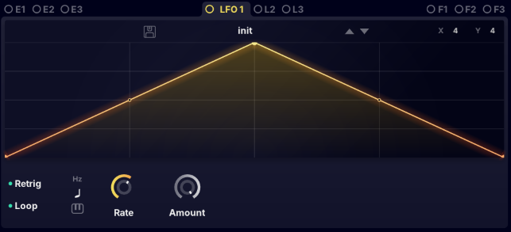
Bend the Curve with the little Handles in the middle of the straight Lines or the yellow Dots. The Amount-Knob let you control how much the Output will affecting the Parameter you attached to. Hold control (mac) / alt (win) key to Snap Handles to the Grid. Setup the Grid on the top right where you see X and Y.

Modulators – F

Frequence Modulators are Pitch by Time Manipulators you can use on the TUN Parameter in the Operators. The Range is from D#0 to D#10.
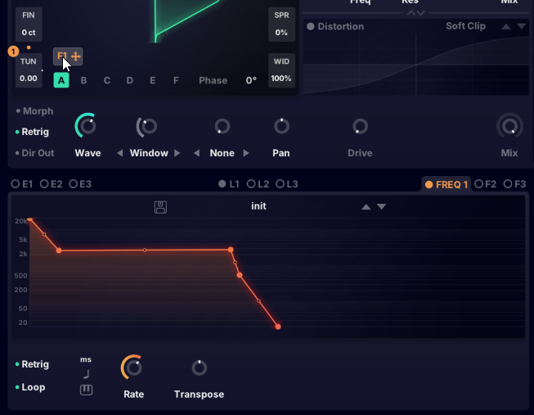
So now you can draw a C4 Note in your DAW and Drag & Drop the F Modulator on TUN of your active Operator. You see the orange 1 if the Modulator is related to the Parameter.
Delete all Handles and adjust the last Handle to around C4. You will notice it is is not very “accurate”. Hold control (mac) / alt (win) key to Snap to Semitones. Drop a second Handle in the Line and adjust it to another Pitch x. Now your C4 Note drives from around C4 to x (what ever you set up).

*Your Note Pitch is now fixed to the F Modulator no matter what pitch you play in the DAW.

Modulators – R

The Random Modulator generates Random Values.
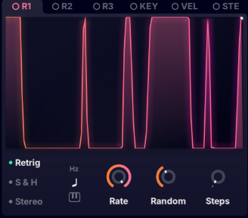
Retrigger repeat a Random Sequence.
S & H captures and takes the voltage of a continuously varying signal and holds (locks, freezes) its value at a constant level for a specified minimum period of time.
Rate is just the Replay Speed with the 3 Measurement Types. Random controls how often Random Values are generated.
Steps controls how many Values in Range (0 to 128) are generated.

Modulators – KEY

Keyboard is used to modulate a Parameter by incoming Midi Pitch.
You can draw MSEG like Curves what note should have how much strength to a Parameter.
That works also for Polyphony.

Modulators – VEL

Velocity (key press speed) is used to modulate a Parameter by the pressed Speed of an incoming Note. To set up the Velocity most DAW’s have a Controller in the Piano Roll per Note. For Live Playing your Device should have Velocity functionality for this Modulator.

Modulators – STE

The Stereo Modulator do something in the Stereofield with the Parameter. “Panorama Shift” explained it very well. Here are no Settings or Parameters to play around.

Effects and Modulation
On the right Side of the Plugin you find the 3 Tabs for the Synth, FX and Modulation Matrix. Now in the Picture you see the active Tab is for the Synthesizer Section you read about above.
Below the Synth is the FX Tab and below the FX Tab you have Access to the Modulation Matrix.

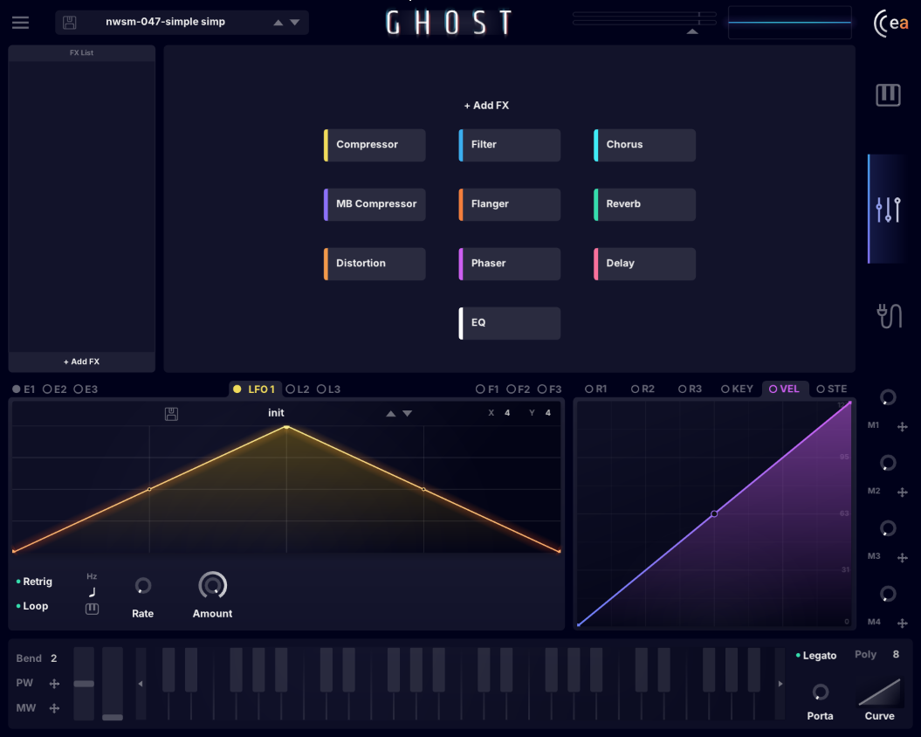
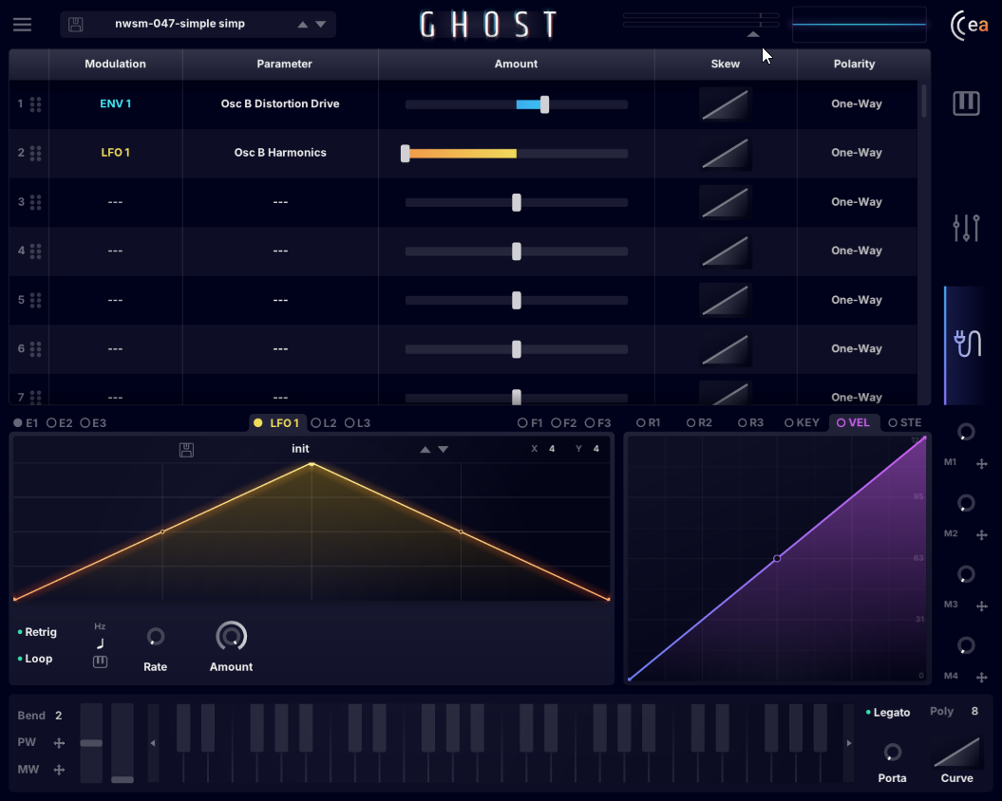
Effects
Mod Matrix

Effects
- 10 stack-able full modulate-able Effects with wicked Visuals
- Drag and Drop or [+Add] to add Effects
- Delete Effects by drag & drop it outside the Frame
- Free to change the Order of the Effects
- Mute Effects by click on the colored bar on the left side
- You can not save Effect Presets

Mod Matrix
In the Mod Matrix you can
- re-arrange Modulations,
- change the Direction and Value of the Modulation
- switch between One Way or Two Way Polarity
- Add Skew to the Movements
- Change all Modulations and the attached Parameters freely

The Keyboard

- Mod Wheel with Modulator
- Pitch Wheel with Modulator
- Bend is for the Pitch Wheel Range
- Legato Switch
- Portamento Knob
- Portamento Curve
- Polyphony Setting max. 16 Voices
- Key Range Shift Buttons
The implemented Keyboard shows you which Key is actually played and is also playable.
The Modwheel and Pitchwheel are additional Modulators for the most external Keyboard Controllers. The Pitchwheel is hard-linked to Pitch. It works like all the other Modulators.

Macro Knobs
- 4 Additional Controllers

